International Journal

Information Technology Applications (ITA)
Volume 7, Number 2, December 2018

TITLE OF YOUR ARTICLE
FONT SIZE 14

Name1 Surname1, Name2 Surname2, ... font size 11
(two blank lines, font size 10)

Abstract: (set up font size 9 for all abstract, keywords and ACM Computing Classification System)

Abstract range is up to 15 lines of text and recommended structure is this: scientific goal, methods, results, conclusions.

Keywords:

Write 3 – 6 keywords.

ACM Computing Classification System:

Write a suitable set of classification names selected from the list:
http://www.acm.org/publications/class-2012.

(two blank lines, font size 10)

Introduction (title has font size 12, all body of article has font size 10)

Scientific contribution is reviewed by two reviewers and the recommended number of pages is approximately 10 pages. Information contribution has recommended number of pages 1–5.
We receive contributions containing theoretical or practical knowledge of the information technology applications in technology, economy, law, enterprise, media, psychology, education, public administration, etc. Our journal is issued twice a year. Send your contribution in electronic form only, using doc/docx format.
Your contribution should contain following parts:

- Abstract
- Keywords
- ACM classification
- Introduction
- State of art concerned to your topics
- Design of research (object, goal, hypothesis, methods of validation, models
and data, evaluation) or design of application (object, goal, technology-software,
data, evaluation, experiences)
- Discussion of results, recommendations or external links to details
- Conclusion of main contribution
- Acknowledgement
- References
(insert Page Break at end of each page)
(two blank lines on the top of page)

1 The Title of First Chapter

Here to place text of the first chapter. Every reference should be cited in text, in this way: [3]. Each reference is written in the language of its origin and translated to English.
When using formulas, they are centered, in form of written text or entered picture. When writing fractioned decimal numbers use dot only: 3.141. When the formulas are referenced in text, they should have the same or similar font size as text and they should be numbered in this way:

$\sin{α}±\sin{β}=2\sin{\frac{1}{2}\left(α±β\right)}\cos{\frac{1}{2}\left(α∓β\right)}$ (1)

Titles of pictures/graphs are written below the pictures: Fig.1. Titles of tables are written on the top of tables, title of table and the body font size 9. References in text to pictures and tables are mandatory and they are written in this way: (fig.1) (tab.1). When using the tables or pictures/graphs, they are centered and the source should be mentioned. Subchapters (subtitle font size 10) are numbered 1.1 and 1.1.1 Times Roman Font, single spacing. Printed version of this journal is black and white only - make all pictures light, sharp and contrast. Online journal keeps color contents. Pictures with many details are recommended to have maximal width of the whole text column. Page size of printed journal is B5 (176 x 250 mm). First page of every article is on the right side of printed journal.

(two blank lines before picture)
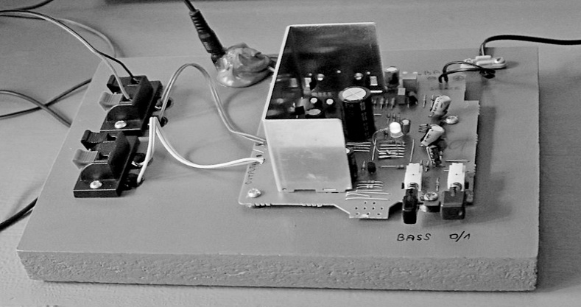
Fig.1. Title and short description of the picture, centered, font size 10.
If there is text inside of picture, it must be readable in print version.
(two blank lines after picture)

Table 1. Title of table above of table and centered, font size 9
text in table has font size 9 | when writing fractioned decimal numbers use dot only: 3.141. | table is centered and has a maximal width of the text column
(insert Page Break at end of each page)

(two blank lines on the top of page)

Conclusion

Text of conclusion.

(two blank lines after each chapter)

Acknowledgement

Not to forget contributors, donors and the Project.

(two blank lines after each chapter)

References

[1] | References are written here into this table layout without visible borderlines, font size 9.  At the end of page the table is to split.
[2] | Korn, A., Korn, M. (2000). Mathematical Handbook for Scientists and Engineers. Dover Publications. 1152 p, ISBN 978-0486411477
[3] | Surname-1, X.,Y., Surname-2, X. (2017). Title of article or contribution.  Title of journal or collection. vol.1, no.1, p.1-10, ISSN 12345678, doi: 12.345…
[4] | Name (2017). Title of webpage or material.  Retrieved June 13, 2017, from http://webpage.address.abc/xyz.pdf

Authors

Prof. Name-1 Surname-1, PhD.
Institution/body/company, City, Country
name-1@address-1.abc
Add here your short professional curriculum: a branch of your study and work, where is it and mention several important results and/or activities.

Prof. Name-2, Surname-2, PhD.
Institution/body/company, City, Country
name-2@address-2.abc
Add here your short professional curriculum: a branch of your study and work, where is it and mention several important results and/or activities.

A comment: some non-consistent details in edited document or something
you were not able to design we will check and fix afterwards.

