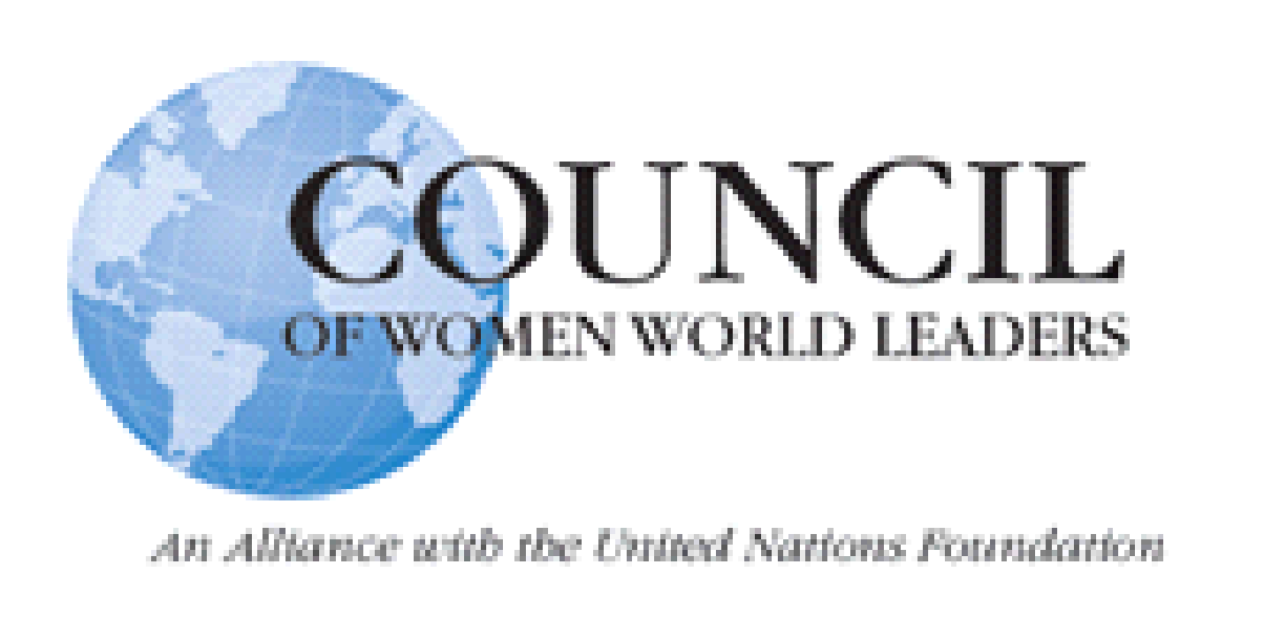

**Saara Kuugongelwa-Amadhila**, *Namibia*

**Doris Leuthard,** *Switzerland*

**Maria Liberia-Peters,** *Netherlands Antilles*

**Sanna Marin,** *Finland*

**Theresa May,** *United Kingdom*

**Mary McAleese,** *Ireland*

**Beatriz Merino,** *Peru*

**Angela Merkel,** *Germany*

**Laura Chinchilla Miranda**,*Costa Rica*

**Mireya Moscoso**, *Panama*

**Maria das Neves**,*São Tomé and Príncipe*

**Roza Otunbayeva**,*Kyrgyzstan*

**Pratibha Patil**,*India*

**Kamla Persad-Bissessar**,*Trinidad and Tobago*

**Michèle Pierre-Louis**, *Haiti*

**Marie-Louise Coleiro Preca**, *Malta*

**Kazimira Prunskienė**, *Lithuania*

**Iveta Radičová**,*Slovakia*

**Dilma Rousseff**, *Brazil*

**Katerina Sakellaropoulou**, *Greece*

**Maia Sandu**, *Moldova*

**Jenny Shipley**,*New Zealand*

**Jóhanna Sigurðardóttir**,*Iceland*

**Maria do Carmo Silveira**,*São Tomé and Príncipe*

**Ingrida Šimonytė**, *Lithuania*

**Portia Simpson-Miller**, *Jamaica*

**Ellen Johnson Sirleaf**, *Liberia*

**Jennifer Smith**,*Bermuda*

**Erna Solberg**, *Norway*

**Simonetta Sommaruga**,*Switzerland*

**Laimdota Straujuma**, *Latvia*

**Hanna Suchocka**, *Poland*

**Megawati Sukarnoputri**,*Indonesia*

**Helle Thorning-Schmidt**,*Denmark*

**Aminata Touré**,*Senegal*

**Yulia Tymoshenko**,*Ukraine*

**Vaira Vīke-Freiberga**, *Latvia*

**Paula-Mae Weekes**, *Trinidad and Tobago*

**Eveline Widmer-Schlumpf**,*Switzerland*

**Sophie Wilmès**,*Belgium*

**Sahle-Work Zewde**, *Ethiopia*

**Begum Khaleda Zia**, *Bangladesh*

**Salome Zourabichvili**, *Georgia*

**Laura Liswood**, Founder & Secretary General,*United States of America*

**Elizabeth Cousens**,President & CEO, UN Foundation,*United States of America*

**Katrín Jakobsdóttir**, Chair, *Iceland*

**Vigdís Finnbogadóttir**, Founding Chair, *Iceland*

**Kim Campbell**,

Chair Emerita, *Canada*

**Kolinda Grabar-Kitarović,** Chair Emerita*, Croatia*

**Dalia Grybauskaitė**,

Chair Emerita*, Lithuania*

**Tarja Halonen**,

Chair Emerita, *Finland*

**Mary Robinson**,

Chair Emerita, *Ireland*

**Madeleine Albright**,

Founding Chair, Ministerial Initiative

*United States of America*

**Margot Wallström**,

Chair Ministerial Initiative *Sweden*

**Mercedes Aráoz**,*Peru*

**Jacinda Ardern**,*New Zealand*

**Gloria Macapagal Arroyo**,*Philippines*

**Michelle Bachelet**, *Chile*

**Joyce Banda**, *Malawi*

**Violeta Barrios de Chamorro**, *Nicaragua*

**Ana Brnabić***, Serbia*

**Gro Harlem Brundtland**, *Norway*

**Micheline Calmy-Rey**, *Switzerland*

**Suzanne Camelia-Römer**, *Netherlands Antilles*

**Zuzana Čaputová,** *Slovakia*

**Tansu Çiller**, *Turkey*

**Helen Clark**, *New Zealand*

**Paula Cox**, *Bermuda*

**Édith Cresson**, *France*

**Viorica Dăncilă,** *Romania*

**Luísa Dias Diogo**, *Mozambique*

**Ruth Dreifuss**, *Switzerland*

**Mette Frederiksen,** *Denmark*

**Park Geun-hye***, Republic of Korea*

**Julia Gillard**, *Australia*

**Pamela Gordon-Banks**, *Bermuda*

**Kolinda Grabar-Kitarović**, *Croatia*

**Ameenah Gurib-Fakim**, *Mauritius*

**Sheikh Hasina**, *Bangladesh*

**Hilda Heine**, *Marshall Islands*

**Atifete Jahjaga**, *Kosovo*

**Emily de Jongh-Elhage**, *Netherlands Antilles*

**Kersti Kaljulaid,** *Estonia*

**Kaja Kallas**, *Estonia*

**Cristina Fernández de Kirchner**, *Argentina*

**Mari Kiviniemi**, *Finland*

**Jadranka Kosor**, *Croatia*

**Chandrika Kumaratunga**, *Sri Lanka*

Thursday, November 18th, 2021

Her Excellency Iveta Radičová

Slovakia

Dear Madam Prime Minister,

On behalf of the Council of Women World Leaders, I would like to thank you for your participation in this year’s Annual Meeting. It was inspiring to hear your commitment to gender equality and the current initiatives upon which you are working. Your perspective and accomplishments in this field are very interesting and will continue to contribute to discourse on these topics.

I would also like to express my deep appreciation for your dedication to inspiring future generations of leaders, specifically women leaders, and for your continued support to the Council. I would like to encourage you to identify yourself as a Council member in future engagements, involve the Council in your gender equality work whenever possible, and rely on each other to strengthen our network. I hope to see all of you in person at next year’s Annual Meeting. Thank you again for your participation and continued support.

Highest regards,

Laura Liswood

Secretary-General

Council of Women World Leaders