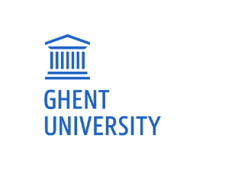

Programme
Staff Training Week
An international perspective on internal quality assurance in higher education
May 11-12-13, 2022 @ Ghent University
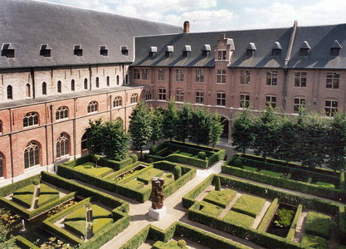

Day 1: 11/05/22: Het Pand, Onderbergen 1

08h30 – 09h00 Meeting in main entrance Het Pand + Registration
09h00 – 09h30 Welcome word and Presentation of Ghent University
Prof. Dr. Ilse De Bourdeaudhuij – Director Department of Educational Policy – Ghent University
09h30 – 10h30 Presentation participants ‘QA in my institution’
10h30 – 11h00: Coffee Break
11h00 – 12h30: Monitors as a self - reflection instrument for monitoring education policy and quality assurance processes at faculty and study programme level
Mrs. Sien Uytterschout – Policy advisor Educational Quality Assurance Office – Ghent University
Mrs. Nele Mahieu – Policy advisor Educational Quality Assurance Office – Ghent University
12h30 – 14h00: Lunch at Het Pand
14h00 – 15h30: European Approach for quality assurance in joint programmes
Mr. Patrick Van den Bosch - Head of VLUHR QA
15h30 – 16h00: Coffee Break
16h00 – 16h30: Round table discussion & conclusions

Day 2: 12/05/22: Het Pand, Onderbergen 1
09h00 – 10h30: Data and monitoring systems in QA @ Ghent University
Mrs. Maya Caen – Policy advisor Department of Educational Policy – Ghent University
10h30 – 11h00: Coffee Break
11h00 – 12h00: Data and monitoring systems in QA other universities – sharing best practices – Q&A
Universidade de Aveiro - Mrs. Sofia Martins & Mrs. Rita Quintela
Universiteit van Amsterdam - Mrs. Alexandra Paffen & Mrs. Tetje Timmermans
Georg-August-Universität Göttingen – Mrs. Christina Höhmann & Mrs. Annegret Schallmann
12h00 – 13h30: Lunch
13h30 – 15h00: Developing a European Approach for Comprehensive QA of (European) University Networks (EUniQ)
Mr. Axel Aerden – Director dept. of Flanders NVAO
15h00 – 15h30: Coffee Break
15h30 – 16h30: Good practices in institutional quality assurance
Prof. Dr. Ilse De Bourdeaudhuij – Director Department of Educational Policy – Ghent University
Mrs. Joke Claeys – Policy advisor Educational Quality Assurance Office – Ghent University
17h30: Social activity and Dinner

Day 3: 13/05/22: Het Pand, Onderbergen 1

09h00 – 10h30: Quality assurance in times of covid 19
Mrs. Elena Cirlan - Senior Policy and Project Coordinator
European Association for Quality Assurance in Higher Education (ENQA)

10h30 – 11h00: Coffee Break
11h00 – 12h00: The external view in contemporary quality assurance
Prof. dr. Lucien Bollaert – Expert international QA
12h00 – 13h30: Lunch and distribution of certificates

